STUDENT NAME: DIANA
LAST NAME: LOUTFI CUCAKOVIC
COURSE: NETWORK APPLICATION DEVELOPMENT L1
SUPERVISOR: MARCIN KACPROWICZ UV
TITLE OF PROJECT: LANGUAGE ACADEMY (PROJECT WORK)

THE TWO OF MY LANGUAGE (LINGUA) ACADEMY PROJECT WORKS:

IN THE FILE THERE IS THE STARTUPS FOR THE TWO LANGUAGE ACADEMY PROJECT APPLICATIONS: HERE AND IN GIT HUB FILE
AND THERE IN MY GITHUB FOLDER THERE IS A LOT OF DOCUMENTATION, PICTURES, PROJECTS, CODES AND START UPS OF THE APPLICATIONS

1: https://localhost:7167/Home/Profile

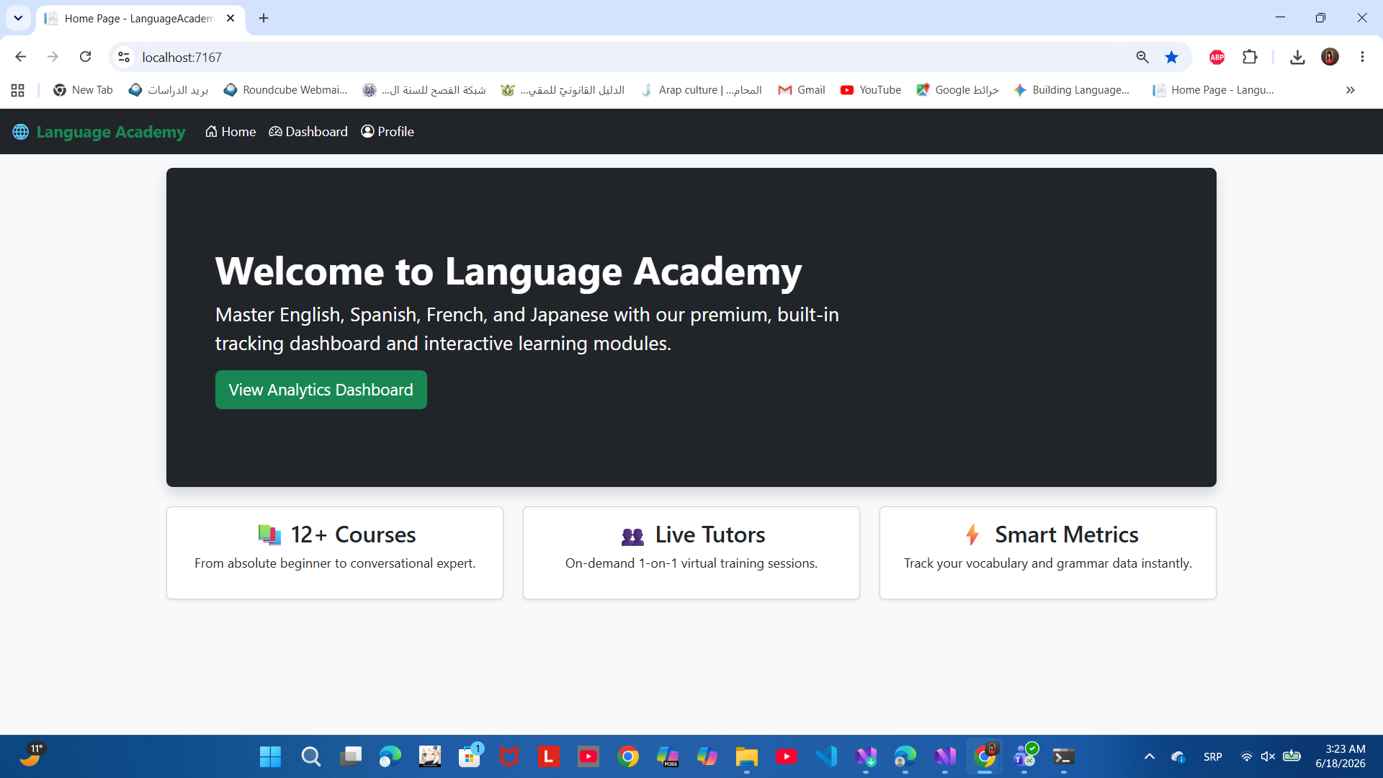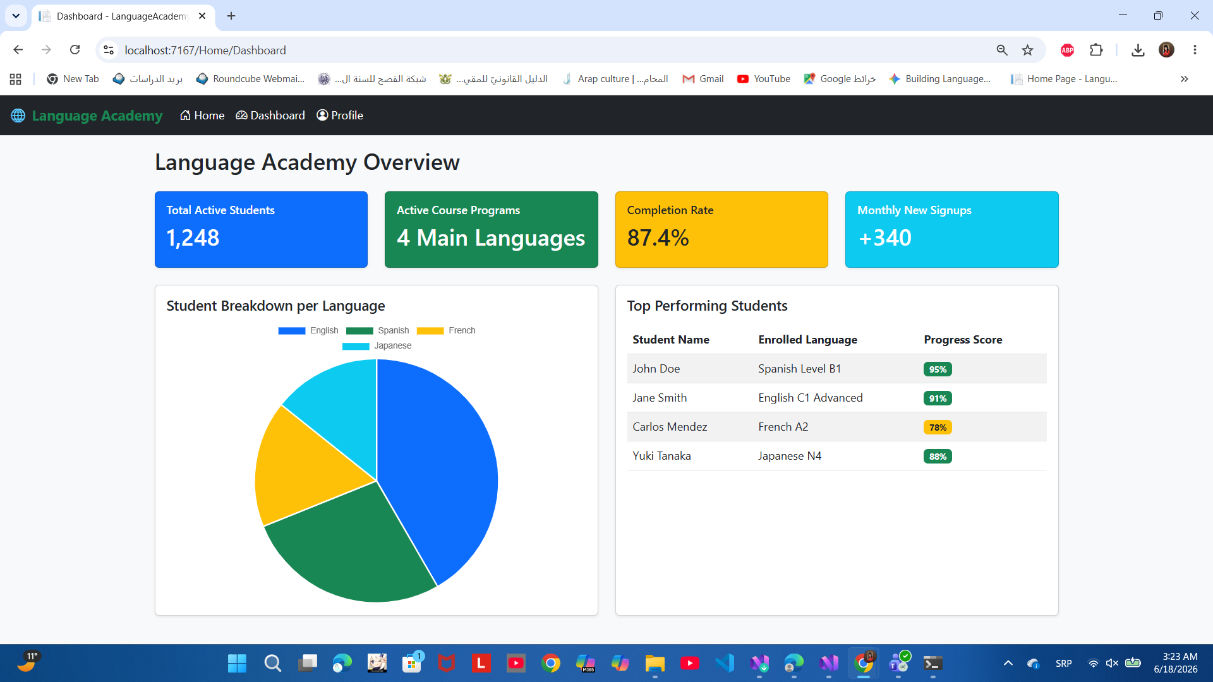
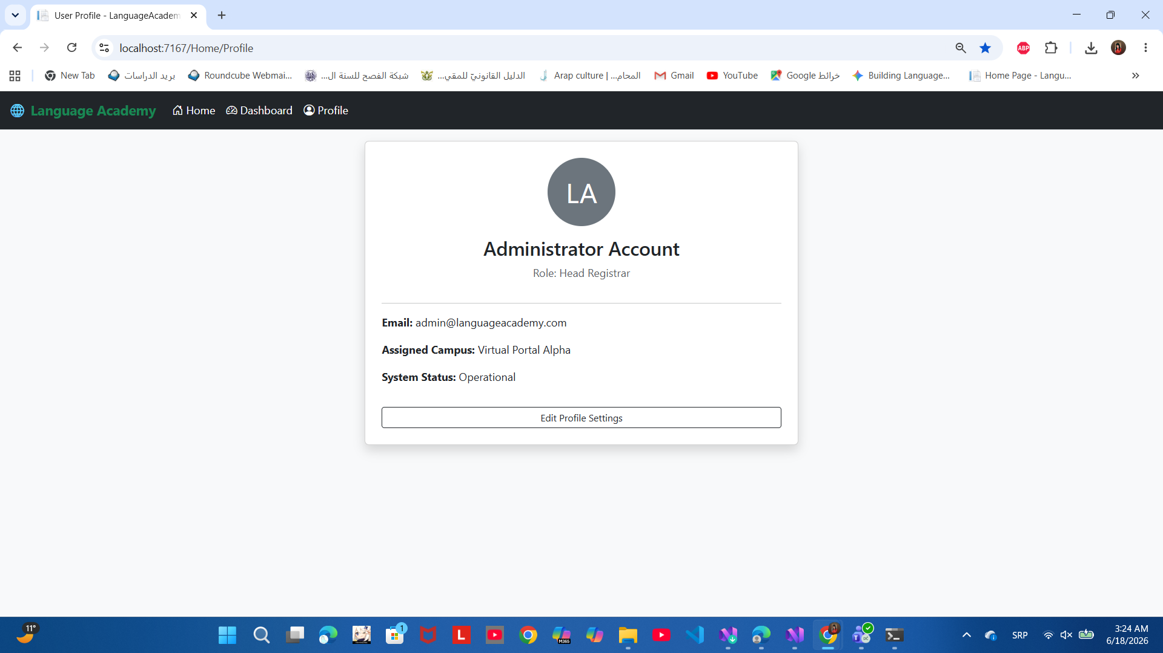

2: http://localhost:62906/Default.aspx

